|  |
| --- |
| Design Project Report |
| Domestic Electricity Bill Monitoring |

By

GROUP-47

D GIRISH (2011188)

DEEPAK KUMAR (2011190)

K AVINASH REDDY (2011251)

KAMATHAM SRINADH (2011197)

VELURU JAYAVANTH REDDY (2011233)

Table of Contents

Table of Contents1

**1.** **Abstract**3

**2. Introduction**4

**3. Problem specifications**4

**3.1 Sub Problems**5

**4. Objective**5

**5. Need Statement**5

**6. Product Specifications**6

**6.1 Qualitative specifications**6

**6.2 Quantitative specifications**7

**7. Concept Generation**7

**7.1 Concept-1**7

**7.2 Concept-2**8

**7.3 Concept-3**9

**7.4 Concept-4**10

**8. Concept Evaluation**11

**9. Embodiment Design**13

**9.1 Parametric Design**13

**9.2 Detailed Design**14

**9.3 Configuration Design**14

**9.3.1 Energy Measuring Unit**14

**9.3.2 Meter Interfacing Unit**16

**9.3.3 Communication Unit**17

**9.3.4 Display Unit1**8

**9.3.5 Tamper Detector**19

**9.4 Exploded View** 20

**9.5 Material Selection**21

**9.6 Ergonomic Factors**21

**10. Prototype Simulations**22

**10.1 Mechanical Part**22

**10.2 Electrical Part**23

**11. Results**24

**12. Conclusions**24

**12.1 Scope**24

**13. References**25

# **1.Abstract**

Our Project focuses mainly on the automation in generating electricity bill, which provides various features like daily updates, tamper detection, power cut info…

The GSM technology has become an essential utility in our life. Everybody has got easy access to it. So, there are a numerous products in market which use this technology and send alerts (alarms) by sensing the emergencies. But, we identified that GSM technology has a scope in electricity bill monitoring which can be used to send messages to users about daily usage and also update database of electricity board by sending statistics.

So, we are intended to design a device (product), which can serve above specified purpose.

To reach our aim objectives we brainstormed various concepts with different mechanisms to find the feasibility and further finalized one of them. We came up with some creative concepts which we detailed with the help of CAD software. Out of these concepts we shortlisted one final concept based on its value proposition. The value was evaluated based on some essential requirements of the device.

After finalizing the concept the technical and aesthetic detailing was completed and finally the design is prototyped. The fabrication was also considered while designing the concepts because the manufacturing cost and relative market cost is the basic factor which will govern the success and user satisfaction of the device.

# **2.Introduction**

The present electricity bill generation is done manually. It’s highly Person dependant. Human errors cannot be avoided. Billing done mainly on estimated/monthly average basis. In rural areas billing is delayed due to lack of manpower.

Meter data is the only data which is used for billing, it cannot help in analysis like demand analysis, energy audit, pinpointing losses, etc.

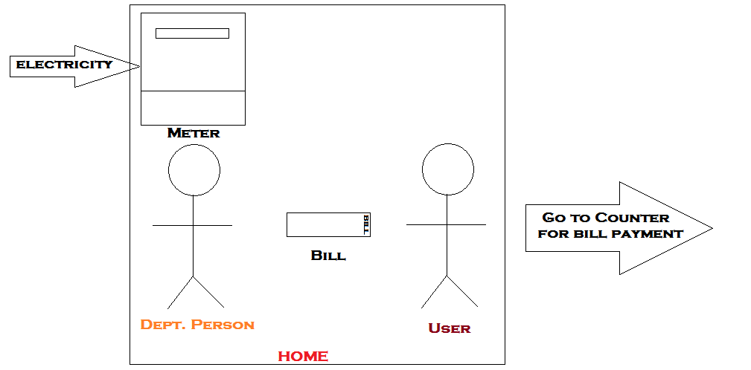

**Fig. Present day system**

**3. Problem specification**

To Generate Electricity Bill, Person must go door to door which delays the process and requires more man power.

**3.1 Sub problems**

* In Villages there are many delays in issuing bill, which makes it difficult for people to pay the bill in time.
* Most of the people pay their bill in cash for which they have to wait in long queues.
* Now-a-days we can see Theft of Electricity in large scale which causes great loss to the electricity department.
* In villages disconnecting the connection is difficult as they threaten the person who come to disconnect connection

**4. Objective**

The main objectives we have set to achieve through the device are

* Reduce Human effort

No person is required to go door to door from issuing a bill.

* Daily updates

Information About daily usage will be sent to the user.

* Reduction of Paper work

Text messages are used instead of paper for issuing a bill. This reduces usage of paper in turn saving trees there by maintaining environmental balance.

**5.Need Statement**

*“To device a system that can send alerts about Daily Usage,Monthly Bills and Other info like powercuts etc to the user and update stats of Electricity Department.”*

**6.Product Specifications**

* Battery backup should be about 12hours.
* Daily alerts should be sent to atleast one mobile.
* 15 V DC
* Digital electricity meter
* Simcard- full size – 2G/3G – 64Kb
* GSM Module
* MAX232 IC
* 60W bulb(used as load)
* Step down tranformer
* Capitors,Resistors,Diodes.
* Processing unit.
* Proximity sensor.
* 16X2 LCD Display.
* Working temperature: -10°C to 80°C
* Relative humidity: 10 to 90%.No condensation.

6.1 Qualitative specifications

1. Easy to interact interface.
2. Capability to with stand high temperatures (at least of for a short span) when used during a fire break-out.
3. Robust enough to withstand impacts when dropped from heights about 6 feet.
4. Must be reliable.
5. Low power consumption when on stand by and when triggered.
6. Should be easy to mount on walls and should rest properly on horizontal surfaces.
7. Stray electric and magnetic fields should not affect / disturb the device.

6.2 Quantitative specifications

1. Battery backup of more than 12 hours.
2. Daily alerts should be sent to atleast one mobile.
3. Size of the device should be less than 8X8X8 inch.

**7.Concept Generation**

**7.1 Concept-1:**

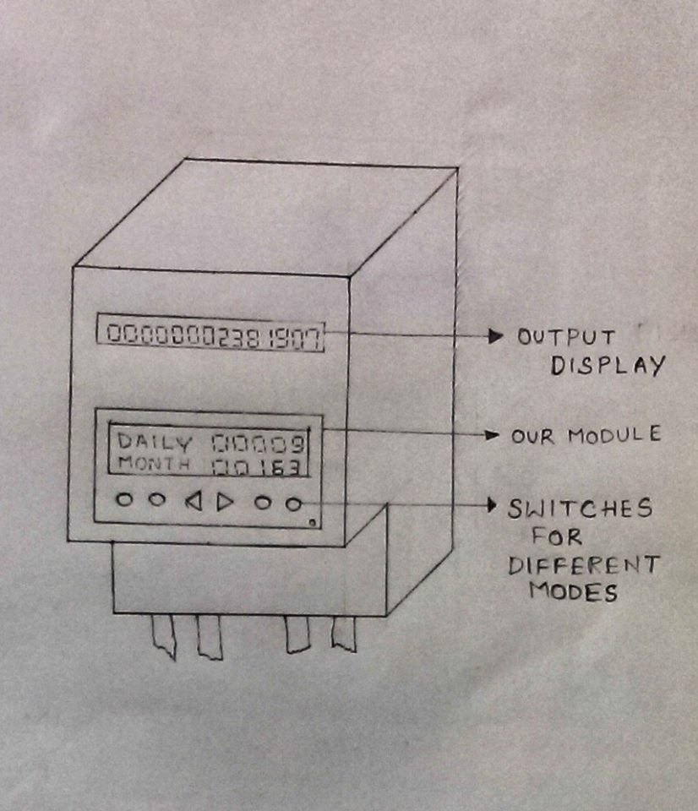

**Fig. Concept-1**

In this concept, we have to change the design of the meter. There are two displays in this meter, one the default display and the other show the daily updates, monthly updates, cost per unit etc. in different modes. To change these modes buttons are provided below the second display. These buttons are designed in such a way that they are easy to navigate.

**7.2 Concept-2:**

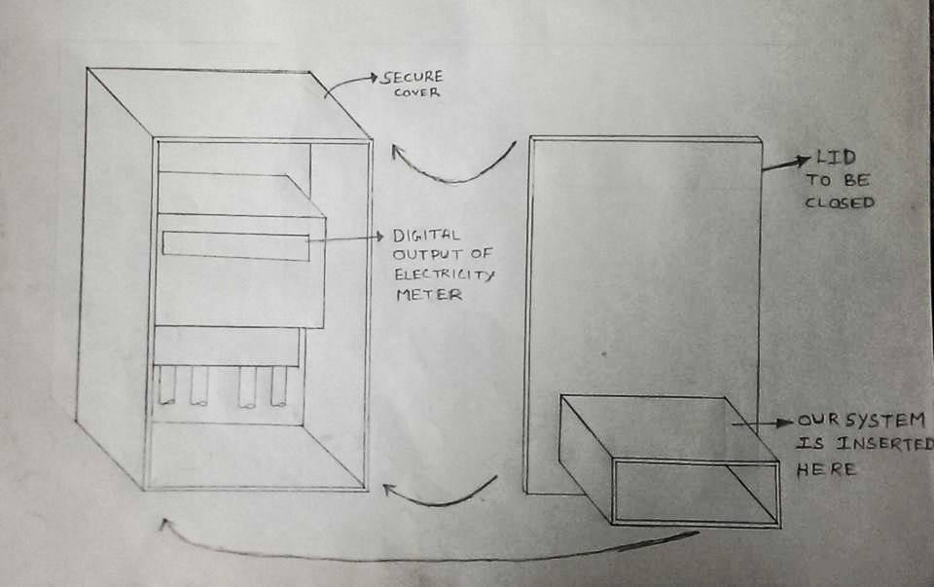

**Fig. Concept-2**

In this concept, the design of the meter is not changed. A separate unit with its own display is connected to the present day meter. This unit takes input from the meter and calculates the no of unit consumed per day and also keeps track of the no of units consumed in that month. These two components are enclosed in a box for extra protection in bad weather conditions in villages.

**7.3 Concept-3:**

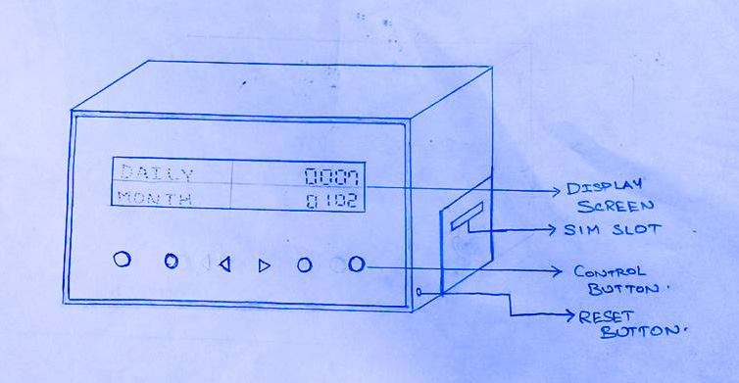

**Fig. Concept-3**

In this design, a portable device is made to communicate with the meter either wired/wireless. This displays the updates and can remotely fixed anywhere in the house.

**7.4 Concept-4:**

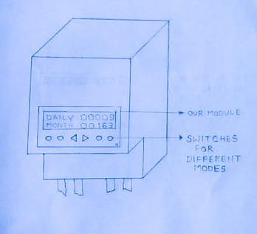

**Fig. Concept-4**

In this concept only one display is provided which shows the updates. This makes it easier for manufacturing and also easy for the user to see the details.

**8.Concept Evaluation**

|  |  |  |  |  |  |
| --- | --- | --- | --- | --- | --- |
| S.No | Parameters | Concept-1 | Concept-2 | Concept-3 | Concept-4 |
| 1 | Size | 7.4 | 6.4 | 6.6 | 7.8 |
| 2 | Portability | 2 | 2 | 8.2 | 2 |
| 3 | Weight | 7.2 | 6 | 7.4 | 7 |
| 4 | Ease in operation | 7.8 | 7 | 8.4 | 7.6 |
| 5 | Aesthetic appeal | 6.8 | 6.8 | 7.6 | 7.8 |
| 6 | Reliability | 7.4 | 7.6 | 7.6 | 7 |
| 7 | Precision | 5.2 | 7.2 | 6.8 | 5 |
| 8 | Installing Cost | 6 | 7.2 | 5 | 6.4 |
| 9 | Ease in installation | 6.2 | 7 | 7.2 | 6.2 |
| 10 | Durability | 6.2 | 9 | 6.4 | 6.4 |
| 11 | Ease in repair | 6 | 7 | 7.6 | 5.8 |
| 12 | Ease in Manufacturing | 7.2 | 8.2 | 7 | 7.2 |
| 13 | Power consumption | 7.2 | 7.2 | 5.8 | 7.6 |
| 14 | Recurring cost | 7.6 | 6.4 | 6.4 | 7.4 |
|  | **TOTAL** | 76.6 | 95.0 | 97.0 | 91.2 |

So as per our evaluation our concept-3 is finalized as it is portable, requires less amount of installation charges and can be manufactured easily. Its cad model is shown below

D:\cad photos\assembly1.tif

**Fig. CAD Model of final Concept**



**Fig. CAD Model Showing internal parts of final Concept**

**9.Embodiment Design**

**9.1 Parametric Design:**

|  |  |
| --- | --- |
| Components | Parameters |
| Digital Energy Meter | Size: 172X180.5X76(mm) |
| GSM Module | Size: 29X29X3.6(mm) |
| Max232 IC | - |
| Li-ion Battery | - |
| 16X2 LCD Display | Size: 70X23(mm2) |
| Capacitors | - |
| Resistors | - |
| Box | Size: 150X100X100 (mm3) |
| Screws | - |
| Wall fixtures | 30X5X100(mm3) |
| Box fixtures | 30X5X100(mm3) |

**9.2 Detailed Design:**

|  |  |  |
| --- | --- | --- |
| Components | Units | Type |
| Digital Energy Meter | 1 | Digital |
| GSM Module | 1 | SIM300 |
| Max232 IC | 1 | - |
| Li-ion Battery | 1 | DC |
| 16X2 Display | 1 | LCD |
| Capacitors | - | Ceramics |
| Resistors | - | - |
| Box | 1 | GI Sheet |
| Screws | - | Mild Steel |
| Wall fixtures | 1 | GI Sheet |
| Box fixtures | 1 | GI Sheet |

**9.3 Configuration Design:**

There are five basic units:

* Energy measuring unit
* Meter interfacing unit
* Communication unit
* Display unit
* Tamper detector

**9.3.1 Energy measuring unit**

Generally power companies will do electricity transmission through transformers. From transformer connection is given to meter and then load is connected to it.

Basically in this unit, it consists of instrument used for measuring power usage. It displays the readings of power usage based load of the electronic devices connected to the meter.

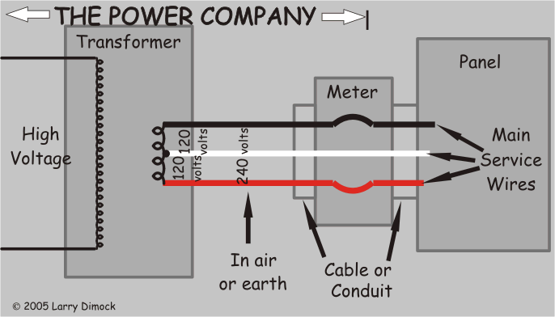

**Fig. Transmission of Power**

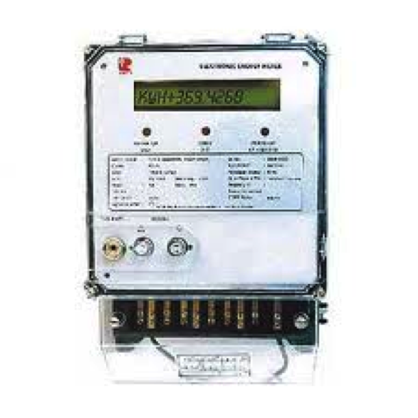

**Fig. Energy Meter**

From the meter the reading will be sent to the meter-interfacing unit, it analyses the data and transfers it to the communication module.

**9.3.2 Meter Interfacing Unit (MIU)**

This unit is connected to the meter from which the data is received. It consists of a micro controller that can analyze the data received from the meter and sends it to GSM module.

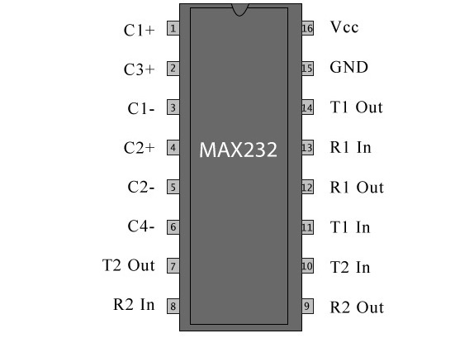

**Fig. Pin Configuration of MAX232 IC**

The MAX232 is an IC, which converts signals from an RS-232 serial port to signals suitable for use in TTL compatible digital logic circuits. It is a dual driver/receiver and typically converts the RX, TX, CTS and RTS signals.

**9.3.3 Communication Unit**

It is used to send a message to the customer about the usage of electricity. In this unit we use GSM module, which helps in sending message to the customer and updates the data in electricity department server. A GSM module is connected to a microcontroller that would transmit data from a meter to cell phone and also receive commend from cell phone to energy meter. **AT** commands, set which energy meter to communicate with the GSM modem, uses stands for attention terminal

We need two wires between this unit and microcontroller/Arduino, one for transmission and other for Reception (TX and RX respectively). Using this modem, you can send SMS, data and read SMS through simple AT command.

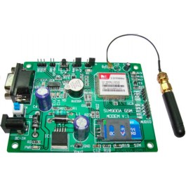

**Fig. GSM Module**

Description: This GSM module is built with the advance SIM300 engine works on frequencies EGSM 900 MHz, DCS 1800 MHz and PCS 1900 MHz It is very compact in size and easy to use as plug in module. The Modem is coming with RS232 interface, which allows you to connect directly to PC or microcontroller /Arduino.

**9.3.4 Display unit**

This unit consists of the LCD display in which entire details will be shown.

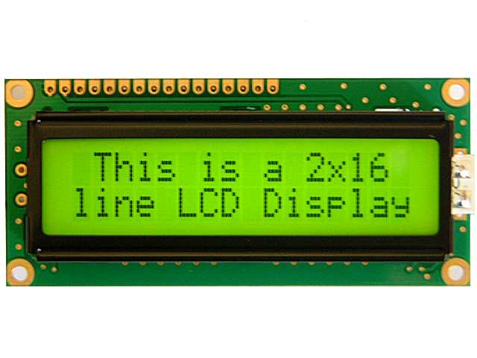

**Fig. LCD Display**

**Liquid crystal display**

A Liquid crystal display are interfaced to microcontroller unit which displays the meter reading, date time, power factor, power status, total load used etc.

**9.3.5 Tamper Detector**

The entire setup discussed above will be placed in a box in which a proximity senor will be placed inside it. That sensor helps in detecting any occurrence of tampering.



**Fig. Proximity sensor**

Here there will be an IR led which will emit IR rays. There is also an IR receiver, which on receiving of IR rays completes the circuit and sends an indication to the microcontroller. If anybody tries to open the box the IR sensor, which is present inside it, detects it and correspondingly sends a message to the electricity department

**9.4 Exploded view**

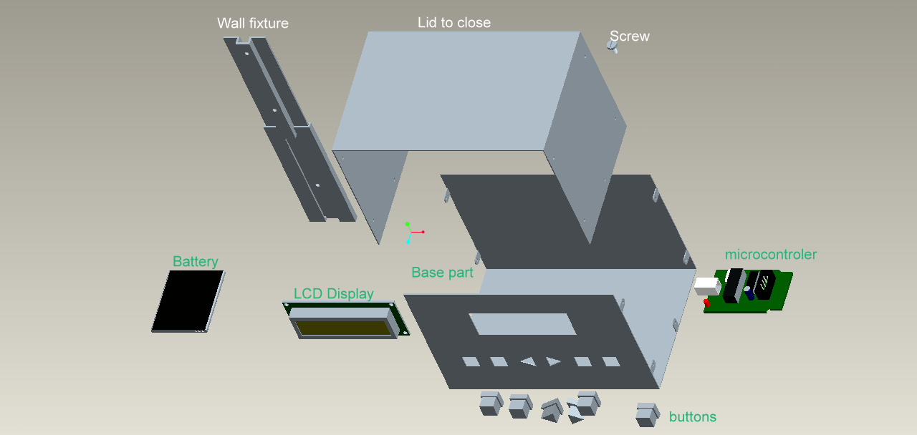

**Fig. Exploded view**

**9.5 Material selection:**

|  |  |  |  |  |  |  |  |
| --- | --- | --- | --- | --- | --- | --- | --- |
| Components | Magnetic Isolation | Cost | Weight | Durability | Cost of Manufacturing | Processing Hardness Level | Overall |
| Aluminum | 4 | 2 | 7 | 8 | 5 | 6 | 32 |
| Acrylic sheet | **7** | **5** | **6** | **7** | **6** | **6** | **37** |
| Plywood | **9** | **6** | **4** | **5** | **6** | **7** | **37** |
| Mild steel | **3** | **3** | **3** | **4** | **4** | **4** | **21** |
| GI sheet | **6** | **4** | **6** | **9** | **8** | **9** | **42** |

Feasible Material: “*GI Sheet”*

**9.6 Ergonomic Factors:**

* Color of Display:

Reading should be visible on Daylight and in Dark.

* + - Black Reading with Green Background.
* Reachability:

Device should be placed at a height such children shouldn’t be able to touch it.

* Clearance:

There should be enough Space between buttons for easy operation.

**10.Prototype**

Prototype simulation

1. Mechanical part
2. Electrical part

**10.1 Mechanical Part**

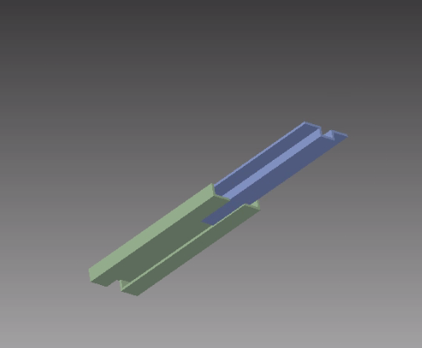

**Fig. cad model of wall fixture**

We have done a simulation related to our Wall fixtures. In this we showed how to fix the device and remove the device.

**10.2 Electrical Part**

We have done a simulation related to our electrical circuit part. In this we showed communication between two microcontrollers one which will be connected to the electricity meter and another, which will be in phone/computer. The microcontroller connected to meter will send a message about the units used in that month through the TX pin to the GSM module that we will be using to communicate.

Here we simulated that without using GSM module through a wired connection between we wrote a program to send data at certain intervals of time to the microcontroller that will be connected to the meter. While that of other we wrote a program to receive the data send by other microcontroller and display it in the LCD (16x2) interfaced to it. Here is a screen shot of that simulation. Here the data send by first microcontroller is ‘53’ as the second microcontroller is displaying the same in the LCD interfacing to it.

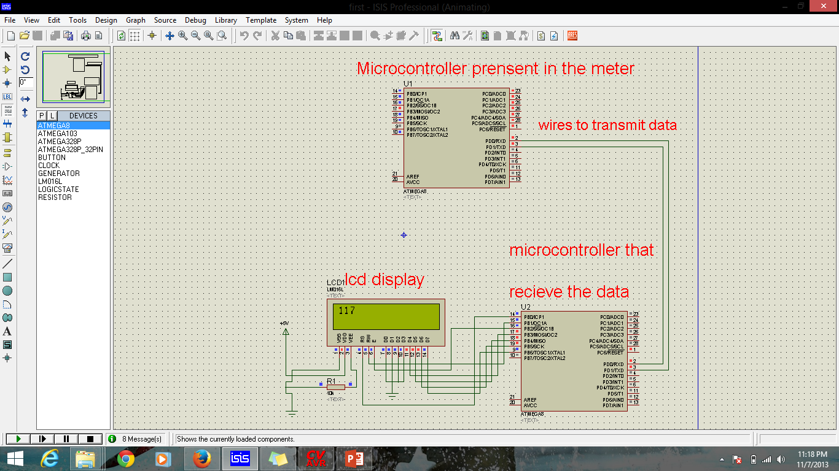

**Fig. Snapshot of Electrical simulation**

**11.Results**

We developed a system using the above mention methods which is as follows. It will solve our main problem and the sub problems also.

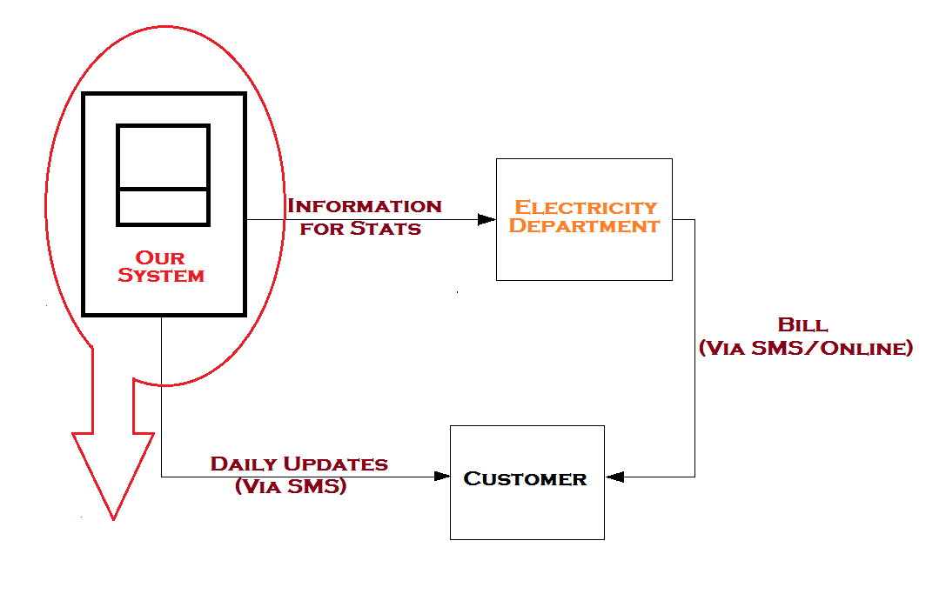

**12.Conclusion**

**12.1 Scope**

* We can link every meter to the ADHAAR card and we can develop a prepaid meter, which will deduct the money from the bank account linked to ADHAAR card.
* Mobile apps can be easily developed with this interface using. Then daily updates may not require SMS because the app will be synced with the server all the time.

**13.References**

* <http://engineersgarage.com>
* <http://wikipedia.com>
* <http://www.google.com>
* <http://robokitsindia.co.in>

|  |
| --- |
|  |